**WORKSHEET 4 SQL**

**Refer the following ERD and answer all the questions in this worksheet. You have to write the queries using**

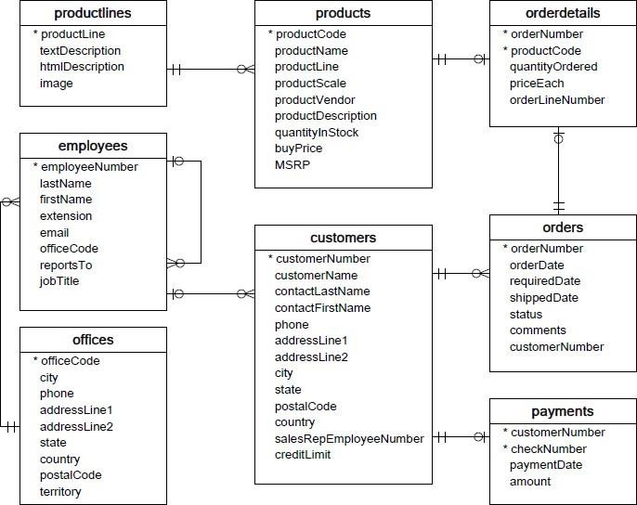

**MySQL for the required Operation.**

**Customers**: stores customer’s data.

• **Products**: stores a list of scale model cars.

• **Product Lines**: stores a list of product line categories.

• **Orders**: stores sales orders placed by customers.

• **Order Details**: stores sales order line items for each sales order.

• **Payments**: stores payments made by customers based on their accounts.

• **Employees**: stores all employee information as well as the organization structure such as who

reports towhom.

• **Offices**: stores sales office data.

**QUESTIONS:**

1. Write a SQL query to show average number of orders shipped in a day (use Orders table).

SELECT shippedDate, Avg (orderNumber) FROM Orders GROUP BY shippedDate;

1. Write a SQL query to show average number of orders placed in a day.

SELECT orderDate, Avg (orderNumber) FROM Orders GROUP BY orderDate;

3. Write a SQL query to show the product name with minimum MSRP (use Products table).

SELECT productname, MIN(MSRP) FROM product;

1. Write a SQL query to show the product name with maximum value of stockQuantity.

SELECT productname , MAX (quantityinstock) FROM products;

1. Write a query to show the most ordered product Name (the product with maximum number of orders).

SELECT productname , MAX(quantityordered) FROM orderdetails INNER JOIN products ON orderdetails.`productcode `= products.`productcode`;

6. Write a SQL query to show the highest paying customer Name.

SELECT customername , MAX(amount) FROM payments INNER JOIN customers ON payments.`customerNumber `= customers.’customerNumber’;

7. Write a SQL query to show cutomerNumber, customerName of all the customers who are from



Melbourne city.

SELECT cutomerNumber, customerName FROM customers WHERE city=’ Melbourne city’ ;

8. Write a SQL query to show name of all the customers whose name start with “N”.

SELECT cutomerName FROM customers WHERE customername LIKE ‘N%’ ;

9. Write a SQL query to show name of all the customers whose phone start with ‘7’ and are from city

‘LasVegas’.

SELECT cutomerName FROM customers WHERE phone LIKE ‘7__’ AND city =‘LasVegas’;

10. Write a SQL query to show name of all the customers whose creditLimit < 1000 and city is either

“Las Vegas” or ”Nantes” or “Stavern”.

SELECT cutomerName FROM customers WHERE creditLimit < 1000 AND city IN (“Las Vegas” , ”Nantes” , “Stavern”);

11. Write a SQL query to show all the orderNumber in which quantity ordered <10.

SELECT orderNumber FROM orderdetailes WHERE quantityordered <10;

12. Write a SQL query to show all the orderNumber whose customer Name start with letter ‘N’**.**

SELECT ordernumber FROM orders WHERE customername LIKE ‘N%’ INNER JOIN customers ON orders.`customerNumber `= customer.`customerNumbere`;

13. Write a SQL query to show all the customerName whose orders are “Disputed” in status.

SELECT customerName FROM customers WHERE status=’Disputed’ INNER JOIN orders ON customers.`customerNumber `= orders.`customerNumber`;

14. Write a SQL query to show the customerName who made payment through cheque with checkNumber starting with H and made payment on “2004-10-19”.

SELECT customerName FROM customers WHERE checkNumber LIKE ‘H%’ AND paymentDate=‘2004-10-19’ INNER JOIN payments ON customers.`customerNumber `= payments.`customerNumber`;

15. Write a SQL query to show all the checkNumber whose amount > 1000.

SELECT checkNumber FROM payments WHERE amount > 1000;